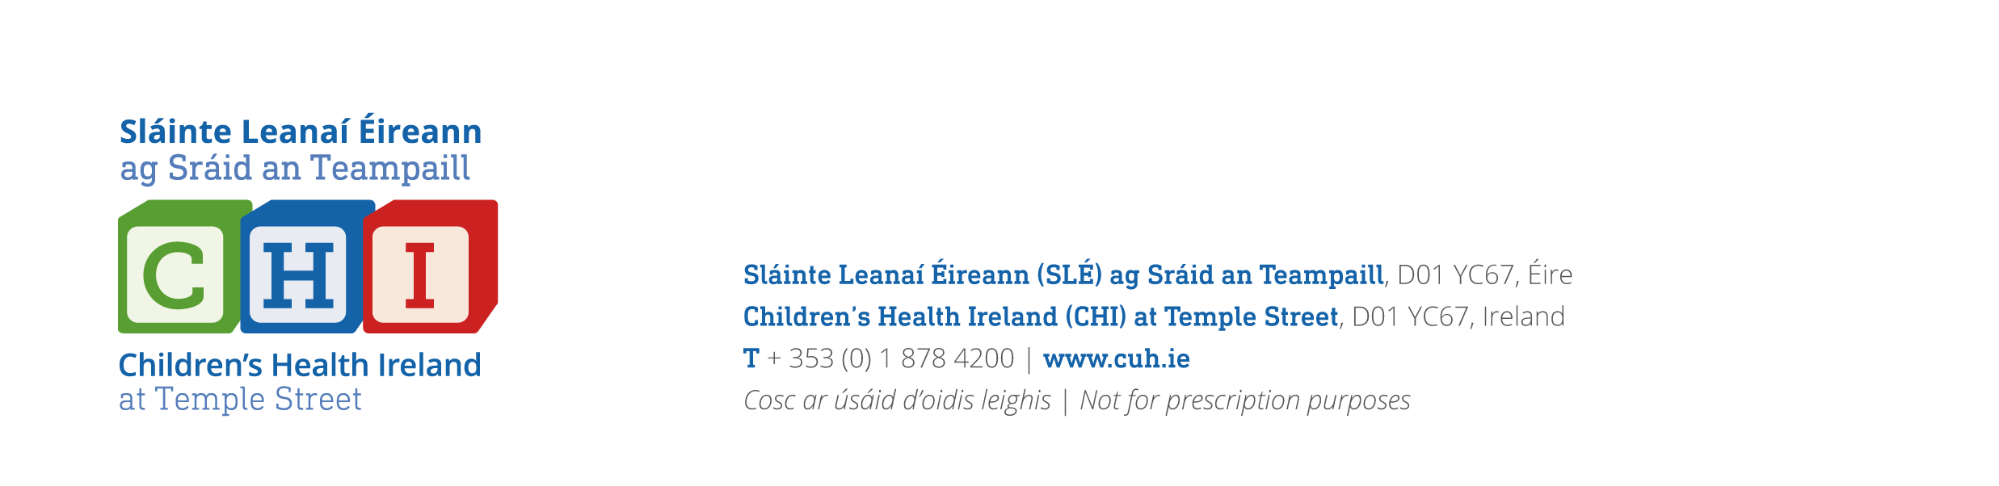

PLEASE FORWARD REFERRALS TO CHI COMPLEX OBESITY SERVICE, CHI TEMPLE STREET, DUBLIN 1, D01 YC67
NEW CHI COMPLEX OBESITY SERVICE REFERRAL FORM
- CHILDREN 2 – 16 yrs old with BMI >99.5th PERCENTILE with 2 of the following COMORBIDITIES secondary to OBESITY:
- UNCONTROLLED METABOLIC COMPLICATIONS
- BIOMECHANICAL COMPLICATIONS REQUIRING TREATMENT OR LIMITED MOBILITY
- SHORTNESS OF BREATH
- SIGNIFICANT PSYCHOSOCIAL COMPLICATIONS OR CONCERNS
- SLEEP DISORDERED BREATHING
- FASTING MORNING BLOODS including LIPID PROFILE, GLUCOSE, INSULIN, CORTISOL, HbA1c, LFTs, TFTs required before
referral can be accepted
- INCOMPLETE FORMS, MISSING BLOOD RESULTS AND CHILDREN WHO DON’T MEET THE ABOVE CRITERIA WILL BE REJECTED
PATIENT DETAILS
Referring Consultant / GP Details:
Name: ____________________________________
Address: __________________________________
__________________________________________
Contact No.: _______________________________
Date of referral: ____________________________
Medical Registration Number:_________________

Name: ____________________________________

Address: __________________________________

__________________________________________

DOB: ___________________________________

ID: ____________________________________

Male: Female:
Guardian Name: ___________________________

Guardian Phone Number : ____________________

Information given and consent obtained from guardian: Y N

Weight (kg) |  | Height (cm) |  | BMI (kg/m²)
BMI centile* |  | Blood pressure (mmHg) |  | Fasting glucose  (mmol/L)
* https://www.rcpch.ac.uk/sites/default/files/2018-03/boys_and_girls_bmi_chart.pdf
PAST MEDICAL, PSYCHIATRIC, SOCIAL AND FAMILY HISTORY:

MEDICATIONS:

COMORBIDITIES:
 | Yes | No |  | Yes | No
Hypertension |  |  | Dyslipidaemia
Type 2 DM |  |  | Poly Cystic Ovarian Syndrome
Sleep Apnoea |  |  | Non Alcoholic Fatty Liver Disease
Orthopaedic |  |  | Underlying genetic diagnosis

ADDITIONAL CONCERNS:
FOR CPD APPROVED EDUCATIONAL MODULES & RESOURCES ON CHILDHOOD OBESITY, PLEASE VISIT WWW.CHILDHOODOBESITY.IE

